Lab 9 (OS) Assignment

Name = Poorab Gangwani

Class = 4B1

Roll-Number = CS191092

Code:

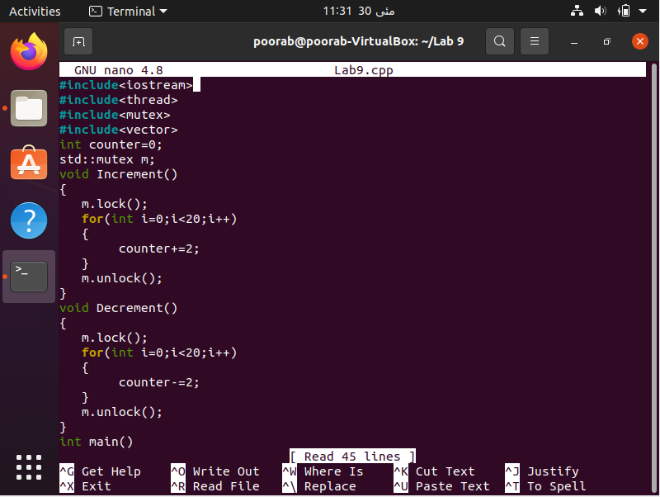

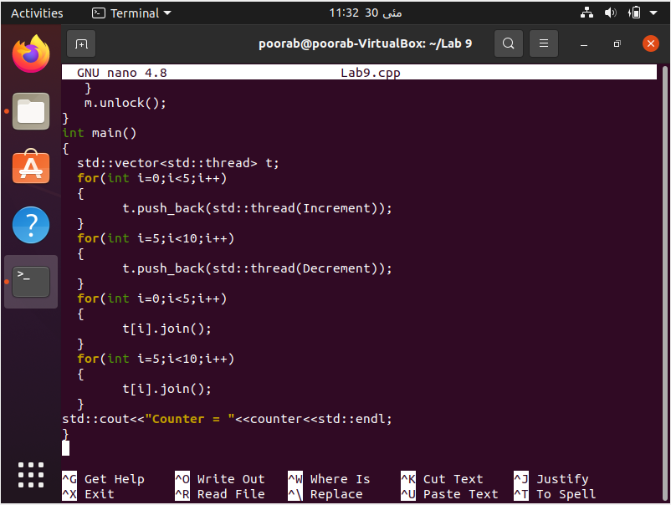

Code Output:

